Removing a kitchen printer
Scenario: The FC needs help removing a kitchen printer.

- Log into the AX5 point-of-sale system with your PIN.
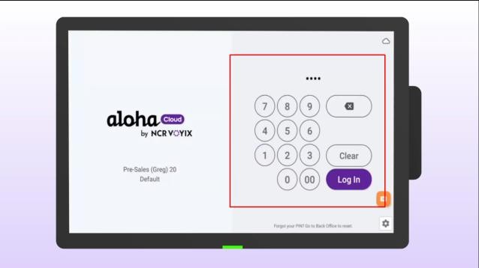
- Click the menu in the top left corner of the screen.
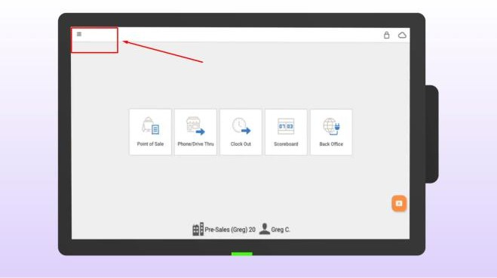
- Select SETTINGS.
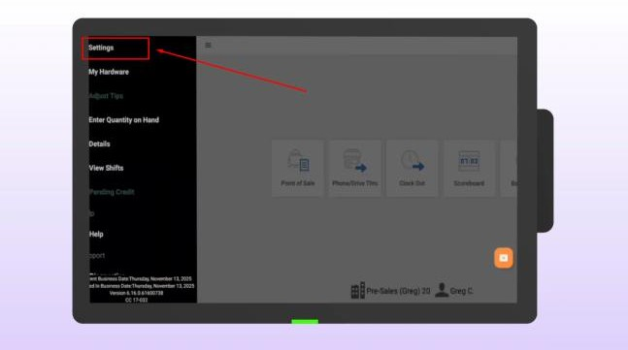

- Select KITCHEN PRINTERS.
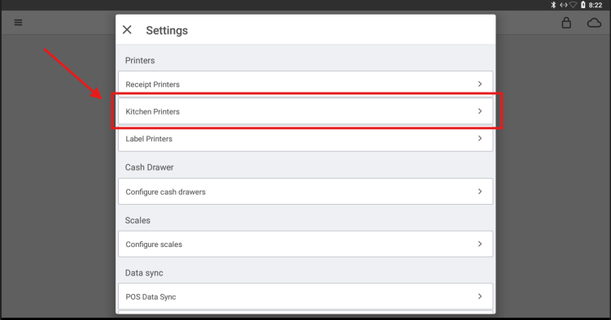
- Press the DELETE button to remove the printer from the device.
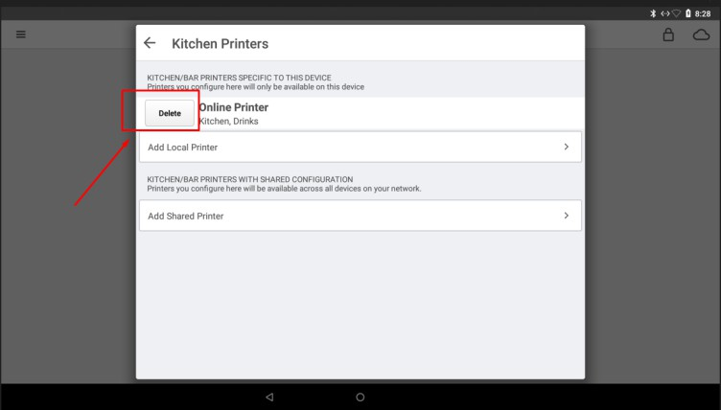
- You have successfully removed the kitchen printer.

